WiFi / USB Microscope Camera
Quick Start Guide
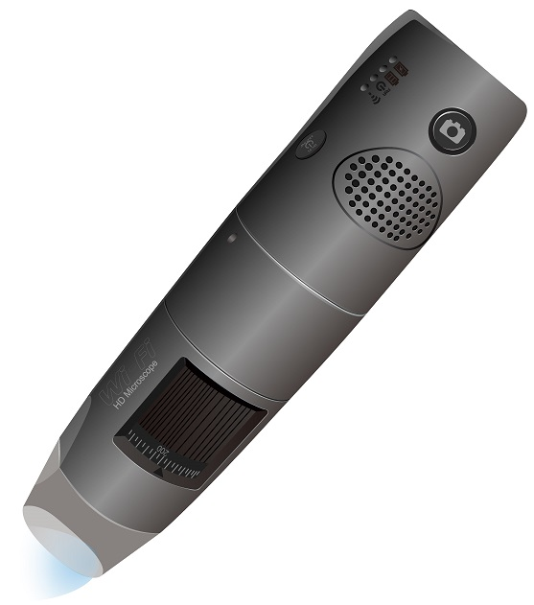

Contents
1. Before you Begin (and why does a “Quick Start Guide” have 30+ pages?) 4
2. Introduction 5
3. Connecting Specific Display Devices with Specific Connection Methods 7
3.1. Windows 10 PC or Tablet via WiFi – Just the Basics 7
3.2. Windows 10 PC or Tablet via WiFi – A Few More Details 8
3.3. Windows 10 PC or Tablet via USB – Just the Basics 13
3.4. Windows 10 PC or Tablet via USB – A Few More Details 14
3.5. iPad or iPhone via WiFi – Just the Basics 17
3.6. iPad or iPhone via WiFi – A Few More Details 18
3.7. Mac via WiFi – Just the Basics 21
3.8. Mac via WiFi – A Few More Details 22
Appendices 25
Appendix 1: Accessing WiFiScope and the Internet Concurrently 25
Case 1: Using a wired ethernet connection 25
Case 2: Using the WiFiScope internal hardware and software as a “bridge” 25
Case 3: Using a Second WiFi transceiver 30
Appendix 2a: USB Connections, Levels and Types -. Just the Basics. 34
Appendix 2b: USB Connections, Levels and Types - . A Few More Details 35
“The Solution”: USB cables, connectors, and capabilities. 35

Figure 1 - Microscope Controls 8
Figure 2 - Connecting the Microscope WiFi signal to a PC, step 1 9
Figure 3 - Connecting the Microscope WiFi signal to a PC, step 2 10
Figure 4 - Connecting the Microscope WiFi signal to a PC, step 3 11
Figure 5 - Connecting the Microscope WiFi signal to a PC, step 4 12
Figure 6 - Video signal from Microscope on the PC 12
Figure 7 - Microscope Controls 14
Figure 8 - Selecting the USB signal 15
Figure 9 - Viewing the video from the Microscope on the PC 16
Figure 10 - Microscope controls 18
Figure 11 - Selecting the WiFi signal step 1 19
Figure 12 - Selecting the WiFi signal step 2 20
Figure 13 - Microscope controls 22
Figure 14 - Microscope controls 22
Figure 15 - Selecting the app 23
Figure 16 - Viewing the Microscope video signal on the Mac computer 24
Figure 17 - Setting up an Internet connection step 1 26
Figure 18 - Setting up an Internet connection step 2 27
Figure 19 -- Setting up an Internet connection step 3a 28
Figure 20- - Setting up an Internet connection step 3b 29
Figure 21- - Setting up an Internet connection step 3c 30
Figure 22 - Device with only one Wifi transceiver attached 31
Figure 23 - Device with more than one Wifi transceiver attached 32
Figure 24 - Multiple WiFi tranceivers 33
Figure 25 - USB Connector types 37

Before you Begin (and why does a “Quick Start Guide” have 30+ pages?)
The WiFi / USB Microscope Camera can be used on Windows 7 / 8 / 10 PCs, Windows 10 Tablets, Apple MACs, Android devices, iPads, and iPhones. And depending on the device can be connected via WiFi or USB or either.
For brevity, this guide will use the generic terms “display” or “display device” .to refer to the “host” that is receiving and displaying the video from the WiFi / USB Microscope Camera, which will similarly be referred to simply as the “camera”.
Everyone should read the Introduction (less than 2 pages), which covers the very basics and a few key important points.
However, after that, most people will only have one type of display and one type of connection to be concerned with - for example, a Windows PC with a USB connection, or an iPad with a WiFi connection. You only need to read the section that applies to your situation and should ignore the other sections to avoid confusion.
In addition, for each display / connection combination there is a “Just the Basics” version and a “Few More Details” section. If you are fairly comfortable with your display device, its OS (Operating System) and using apps in general, this may be all you need and is generally less than a page long.
If you are a little less experienced, or prefer visuals in the directions, the “Few More Details” section is for you. This section is longer that the “basic” version but note that the process is exactly the same as in the “basic” section and the longer length is due to multiple “screen shots” and diagrams, with more detailed specifics on each step.
If you are using multiple displays / connection methods, you will need to read more than one of these sections, but again do not need to read anything that does not apply to your situation.
Finally, there are a few appendices to address some specific issues in more detail, and only need to be read if they apply to your specific case, or you just want a deeper understanding of that issue.
So, for many people, about four pages -this “Before you Begin” section (1 page) the Introduction (2 pages) and “The Basics” (for your device, 1 page) is all you need. And if you need a “Few More Details”, that adds 3-5 more pages, but are mostly pictures, and should be quick and simple to understand.
Finally, please note that this “Quick Start” Guide is intended to help people that may have various levels of technical understanding of the items covered, and is not intended to be a comprehensive guide to the devices or technologies involved.

Introduction
The WiFi / USB Microscope camera can be used on a wide variety of display devices and two different connection methods. The proper way to set up and use the camera is specific, and different for each of these situations.
This guide assumes you have already installed the appropriate app on your display device. How to do this is covered in the documentation that comes with the camera.
On Windows 7 / 8 / 10 PCs, Windows 10 Tablets and MAC PCs, the video signal can be accessed via a WiFi signal or via a USB cable.
On Android devices, iPads and iPhones, the signal can only be accessed via WiFi.
It is easy to make these connections, but there are some key points that need be understood to avoid difficulties:
The method to access the video signal is different for WiFi and USB
The steps to access the signal must be done in a precise order
Special comments when using WiFi:
- Internet access is not necessary when using the camera via WiFi, as the camera generates its own WiFi signal that your display device connects to for conveying the video signal.
- This also means that you will lose your connection to the Internet while using the camera via WiFi. However, if this is a problem, there are three ways around this. These are described in the “Accessing WiFiScope and the Internet Concurrently” section in the Appendix.
Special comments when using a USB connection to a Windows 10 Tablet
- The USB cable supplied with the camera only has a USB-A connector on the “host” connection end of the cable, and most tablets have a USB-C connector (and do not have a USB-A connector), so when connecting the camera to the tablet via USB connection, you need an additional cable can bridge that gap.
This cable:
  - needs to have a USB-A (female) connector on one end and a USB-C (male) connector on the other end.
  - must be USB 3.1 and OTG (“On-The-Go”) compatible.
These characteristics are usually specified in the title or the description of the cable, so be sure any cable you get meets these criteria.
There is additional information on USB connections in the Appendix.

Connecting Specific Display Devices with Specific Connection Methods

Windows 10 PC or Tablet via WiFi – Just the Basics

- Do not attach the USB cable to the display device - it can be plugged into its power source if need be, although it's generally best if the microscope camera is fully charged before using.
- Make sure the dial that controls the level of the illumination LEDs is set to maximum (you can adjust it later as necessary).
- Turn on the camera by pressing the power button for 2-5 seconds.
- Wait for the illumination LEDs to turn on; this may take up to 20 seconds.
- Connect the camera's WiFi signal to the display device's WiFi receiver via the device’s OS WiFi software connection.
- Open the camera’s app on the display device.
- Select the "WiFi" icon within the app, and you should see the video signal, and are ready to start using the camera and the app.

Windows 10 PC or Tablet via WiFi – A Few More Details
- Do not attach the USB cable to the display device - it can be plugged into its power source if need be, although it's generally best if the microscope camera is fully charged before using
- Make sure the dial that controls the level of the illumination LEDs is set to maximum (you can adjust it later as necessary).
- Turn on the camera by pressing the power button for 2-5 seconds
- Wait for the illumination LEDs to turn on; this may take up to
20 seconds)
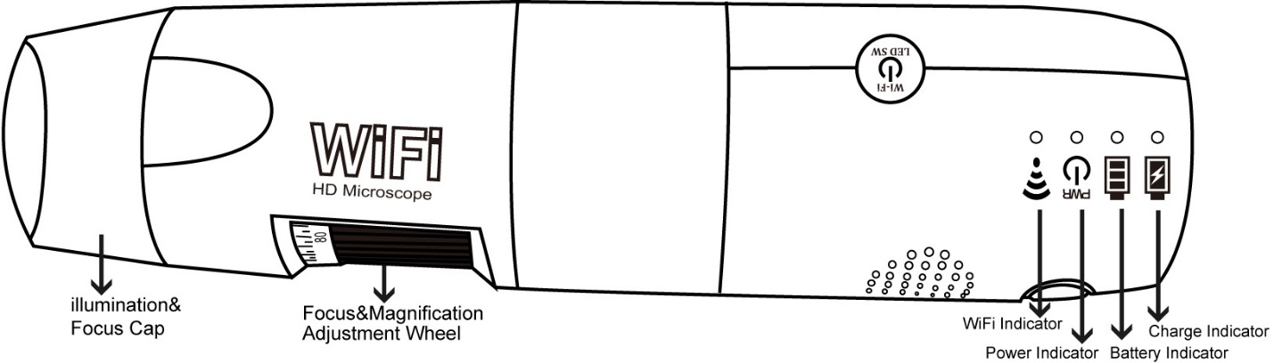
Figure 1 - Microscope Controls

- Connect the camera's WiFi signal to the display device's WiFi receiver via the device’s OS WiFi software connection.
In the screen shot below, the display device is currently connected to the Internet via the “ATT66kwN2I” signal, and the signal from the “WiFiSCOPE-04DF54” is detected, but not yet connected to the device (note: the “04DF54” part of the signal name will be different for your device, as each microscope has its own SSID).
Select the camera’s WiFiScope signal to connect the WiFiScope to your display device:
  - The first time you connect, you will probably have to provide the WiFiScope’s password. The default password is 12345678.
  - Depending on your security situation, you may want to change that password; that is covered in separate documentation.
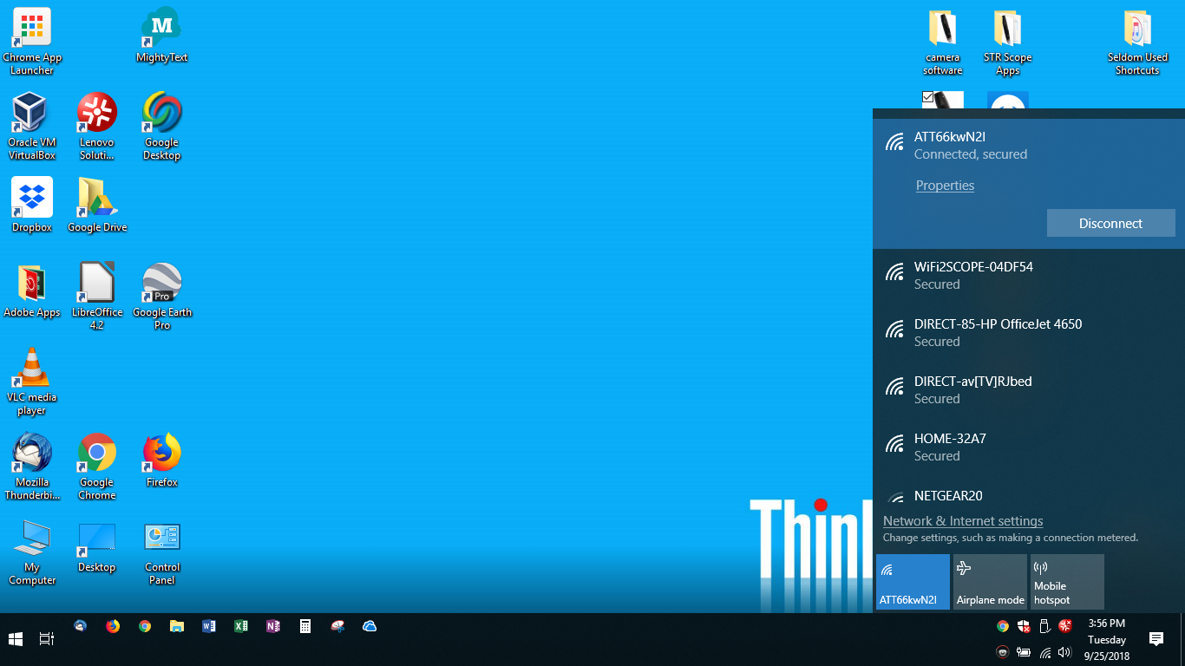
Figure 2 - Connecting the Microscope WiFi signal to a PC, step 1

In the screenshot below, the WiFiScope signal is selected, and ready to connect.
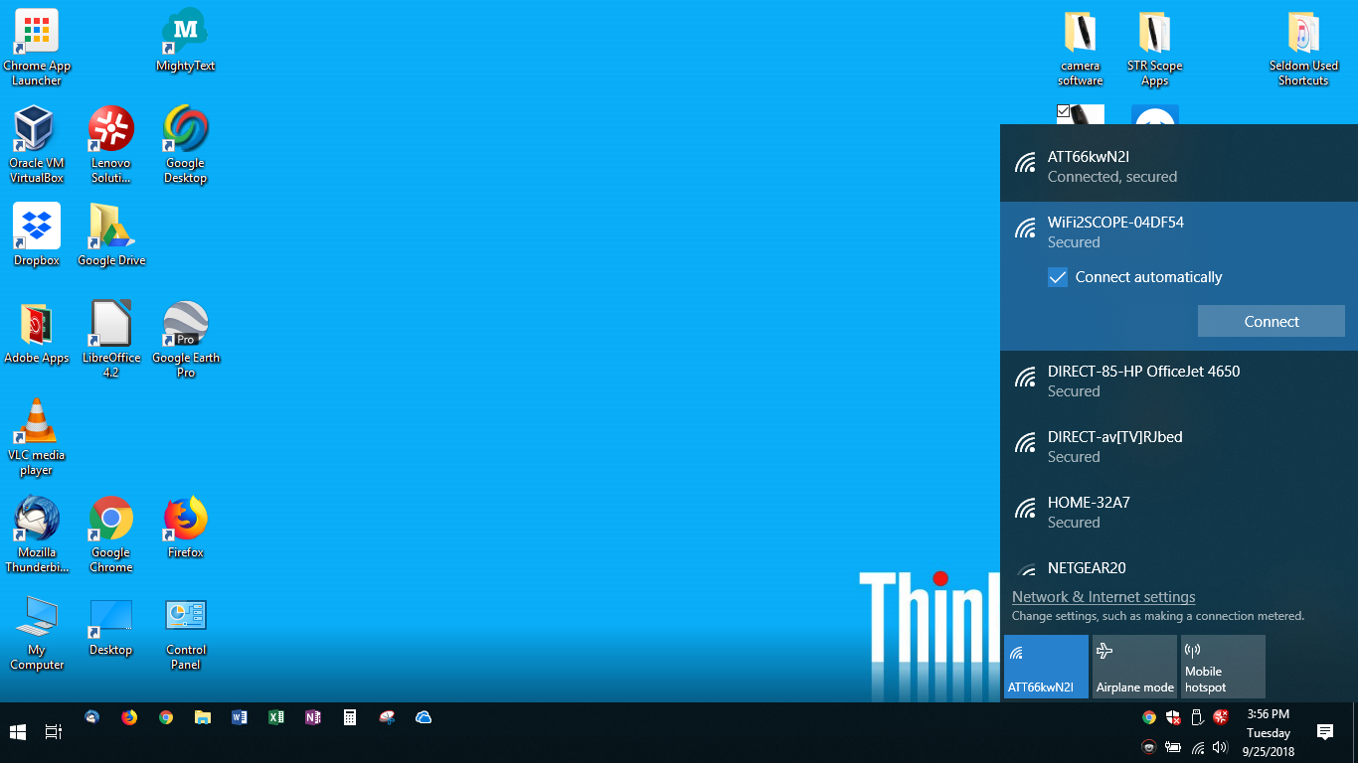
Figure 3 - Connecting the Microscope WiFi signal to a PC, step 2
And the screenshot below shows the microscope is connected.
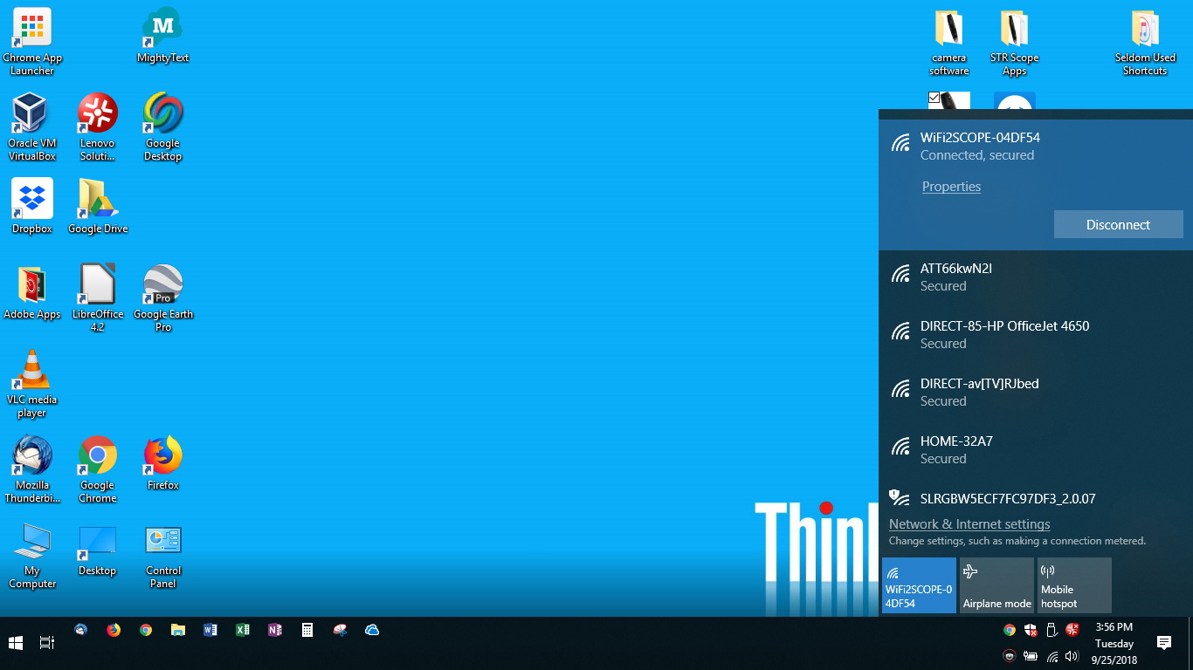
Figure 4 - Connecting the Microscope WiFi signal to a PC, step 3

- Open the camera’s app on the display device.

- Select the “WiFi” icon within the app.
The screen below is before selecting the WiFi icon, “Connect WiFi Microscope”

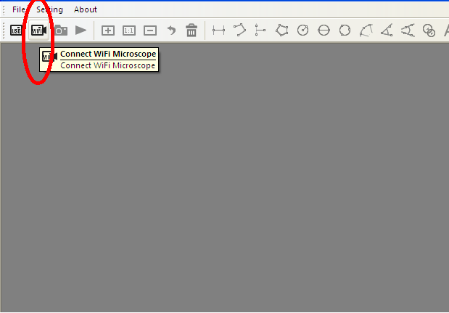
Figure 5 - Connecting the Microscope WiFi signal to a PC, step 4
Select the "WiFi" icon within the app, and you should see the video signal, as shown below:
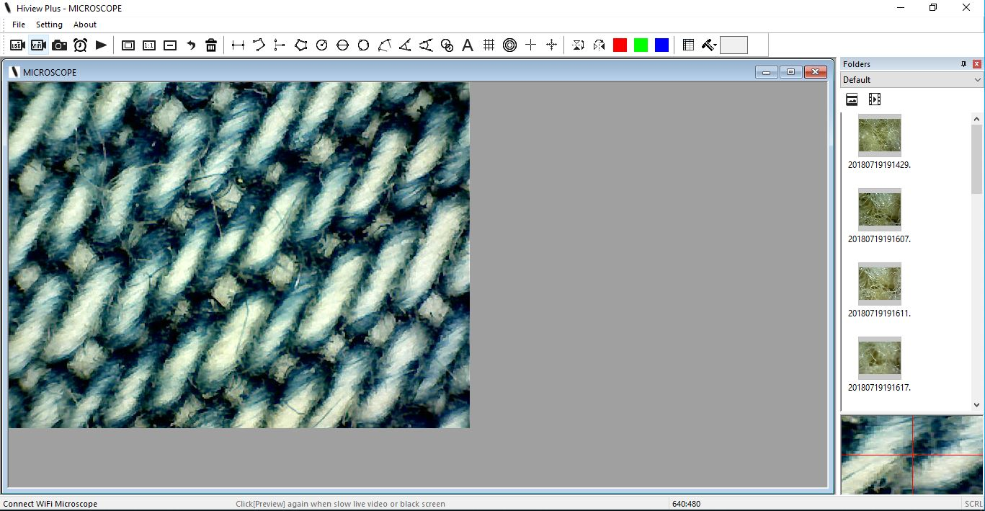
Figure 6 - Video signal from Microscope on the PC
You are now ready to use the camera and the app.

Windows 10 PC or Tablet via USB – Just the Basics

- Make sure the camera is turned off - the illumination LEDs should be off. If you had previously used the camera via WiFi, it would not hurt to make sure the display device is not trying to re-connect to the WiFi signal (with the camera off this should not be an issue).
- Make sure the dial that controls the level of the illumination LEDs is set to maximum (you can adjust it later as necessary).
- Connect the USB cable to the display device.
Note: do not turn the camera on via the power button - doing this puts the camera in WiFi mode and the USB signal is turned off.

- Open the camera’s app on the display device.
- Select the "USB" icon within the app. Within a few seconds the illumination LEDs should light, and you should see the video signal.
You are now ready to use the camera and the app.

Windows 10 PC or Tablet via USB – A Few More Details

- Make sure the camera is turned off - the illumination LEDs should be off. If you had previously used the camera via WiFi, it would not hurt to make sure the display device is not trying to re-connect to the WiFi signal (with the camera off this should not be an issue).
- Make sure the dial that controls the level of the illumination LEDs is set to maximum (you can adjust it later as necessary).
- Connect the USB cable to the display device.
Note: do not turn the camera on via the power button - doing this puts the camera in WiFi mode and the USB signal is turned off
Illumination LEDS should be off (until step 5). Do not press the Power button!
USB cable to display
Figure 7 - Microscope Controls

- Open the camera’s app on the display device

- Select the "USB" icon within the app.
Figure 8 - Selecting the USB signal
- Within a few seconds the illumination LEDs should light, and you should see the video signal, as shown below:
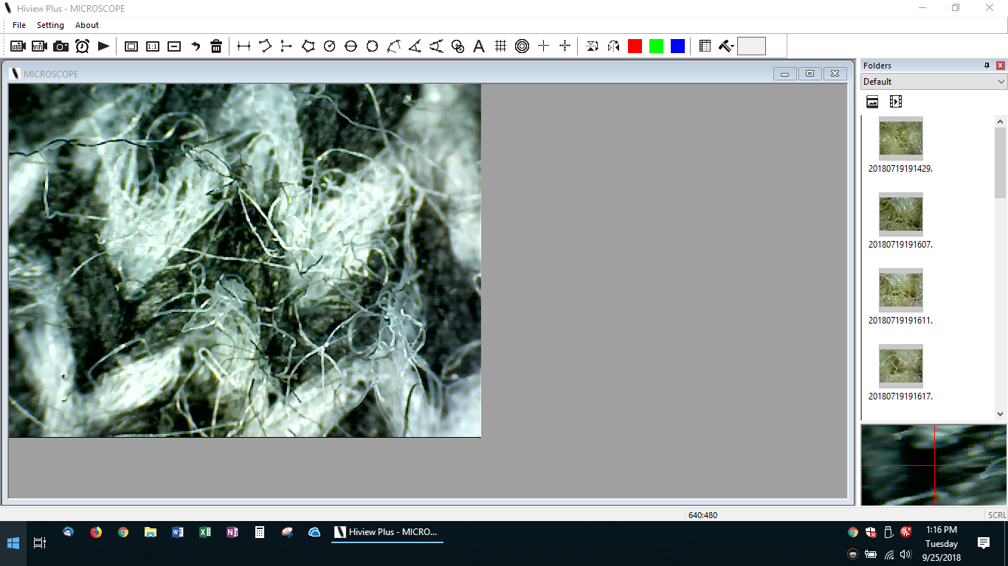
Figure 9 - Viewing the video from the Microscope on the PC
You are now ready to use the camera and the app.

iPad or iPhone via WiFi – Just the Basics

- Do not attach the USB cable to the display device - it can be plugged into its power source if need be, although it's generally best if the microscope camera is fully charged before using.
- Make sure the dial that controls the level of the illumination LEDs is set to maximum (you can adjust it later as necessary).
- Turn on the camera by pressing the power button for 2-5 seconds.
- Wait for the illumination LEDs to turn on; this may take up to 20 seconds.
- Connect the camera's WiFi signal to the display device's WiFi receiver via the device’s OS WiFi software connection.
- Open the camera’s app on the display device.
You should see the video signal, and are ready to start using the camera and the app.

iPad or iPhone via WiFi – A Few More Details

- Do not attach the USB cable to the display device - it can be plugged into its power source if need be, although it's generally best if the microscope camera is fully charged before using.
- Make sure the dial that controls the level of the illumination LEDs is set to maximum (you can adjust it later as necessary).
- Turn on the camera by pressing the power button for 2-5 seconds
- Wait for the illumination LEDs to turn on; this may take up to
20 seconds)
Figure 10 - Microscope controls

- Connect the camera's WiFi signal to the display device's WiFi receiver via the device’s OS WiFi software connection.
In the screen shot below, the display device is currently connected to the Internet via the “Verano2.4Ghz” signal, and the signal from the “WiFiSCOPE-04DF54” is detected, but not yet connected to the device (note: the “04DF54” part of the signal name will be different for your device, as each microscope has its own SSID).
Select the camera’s WiFiScope signal to connect the WiFiScope to your display device:
  - The first time you connect, you will probably have to provide the WiFiScope’s password. The default password is 12345678.
  - Depending on your security situation, you may want to change that password; that is covered in separate documentation.
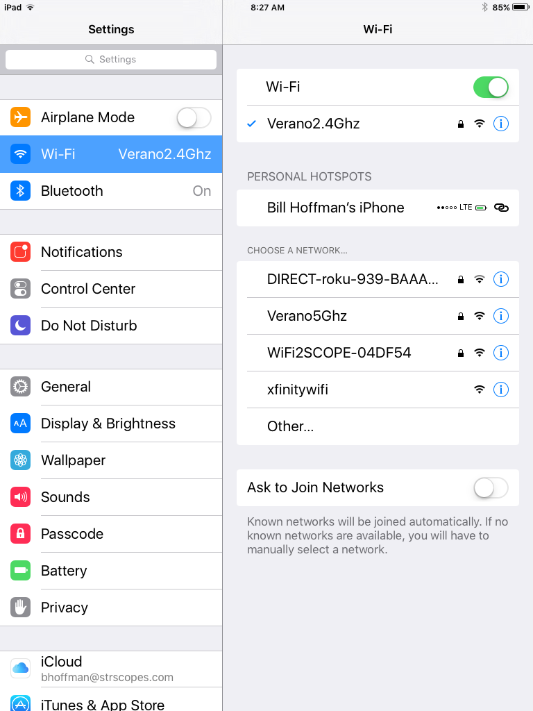
Figure 11 - Selecting the WiFi signal step 1
And the screenshot below shows the microscope is connected.
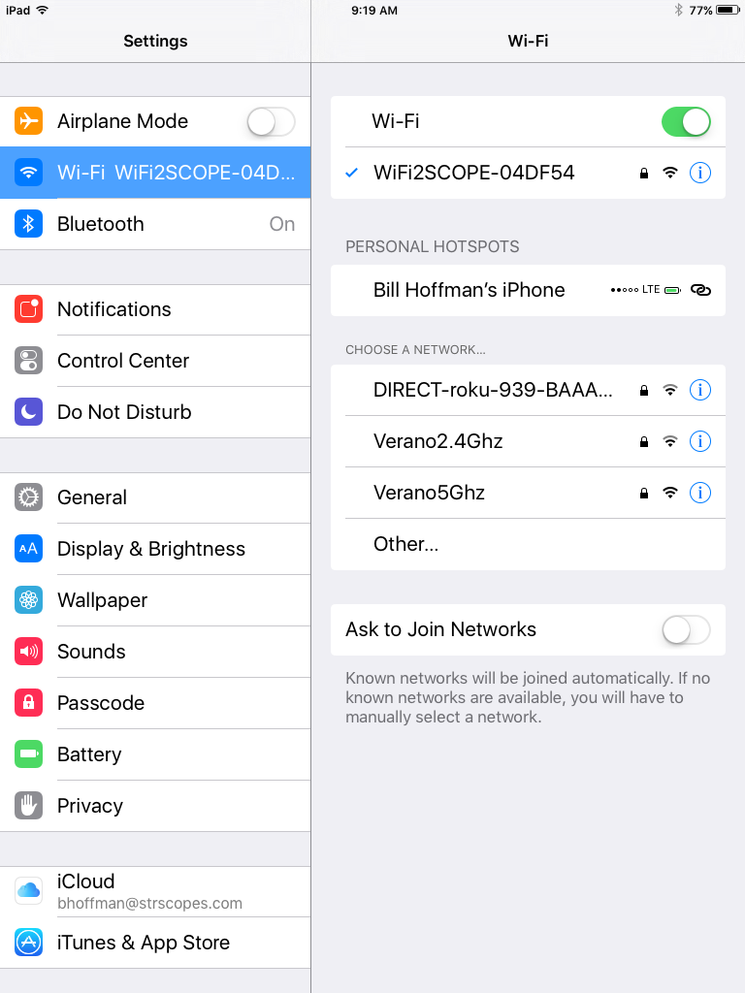
Figure 12 - Selecting the WiFi signal step 2

- Open the camera’s app on the display device.
You should see the video signal, and are ready to start using the camera and the app.

Mac via WiFi – Just the Basics

- Do not attach the USB cable to the display device - it can be plugged into its power source if need be, although it's generally best if the microscope is fully charged before using.
- Make sure the dial that controls the level of the illumination LEDs is set to maximum (you can adjust it later as necessary).
- Turn on the camera by pressing the power button for 2-5 seconds.
- Wait for the illumination LEDs to turn on; this may take up to 20 seconds.
- Connect the camera's WiFi signal to the display device's WiFi receiver via the device’s OS WiFi software connection.
- Open the camera’s app on the display device.
You should see the video signal, and are ready to start using the camera and the app.

Mac via WiFi – A Few More Details

- Do not attach the USB cable to the display device - it can be plugged into its power source if need be, although it's generally best if the microscope camera is fully charged before using.
- Make sure the dial that controls the level of the illumination LEDs is set to maximum (you can adjust it later as necessary).
Set Illumination LED Dial to Maximum.
Figure 13 - Microscope controls
- Turn on the camera by pressing the power button for 2-5 seconds.
- Wait for the illumination LEDs to turn on; this may take
up to 20 seconds.
Figure 14 - Microscope controls

- Connect the camera's WiFi signal to the display device's WiFi receiver via the device’s OS WiFi software connection.
- Open the camera’s app on the display device
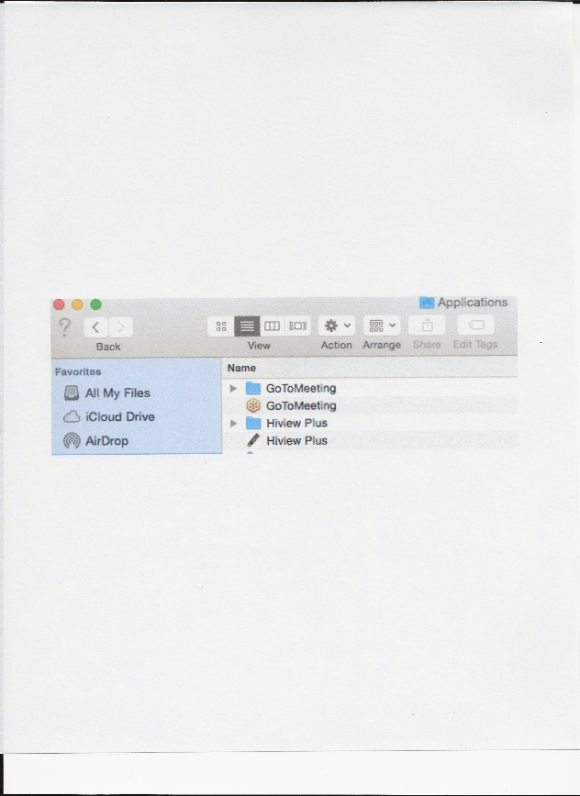
Figure 15 - Selecting the app

You should see the video signal, and are ready to start using the camera and the app.
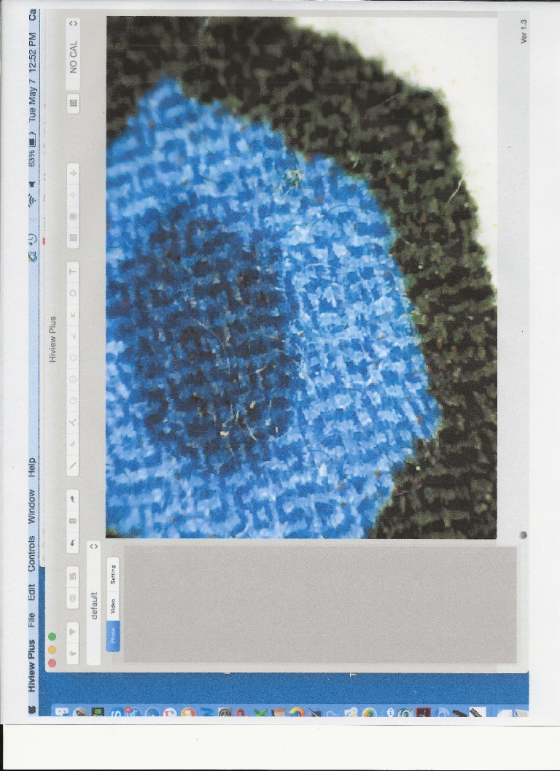
Figure 16 - Viewing the Microscope video signal on the Mac computer

Appendices

Appendix 1: Accessing WiFiScope and the Internet Concurrently

As mentioned in the Introduction, connecting the WiFiScope to your device causes your device to lose its connection to the Internet, as the WiFi hardware can only access one signal at a time (and most devices only have one WiFi connection built-in).
However, there are three ways around this problem. The first is the simplest but may be impractical in most cases. It is included here for completeness, and for those cases where it is practical. The other two do involve some manipulation of your device’s connections.

Case 1: Using a wired ethernet connection
Many devices (with the probable exception of most tablets) have a built-in ethernet port. If the display device has that, and you have an appropriately long ethernet cable to run from your device to your router, you can just connect the two that way.
This will work, but of course has some practical drawbacks. The display device needs to be reasonably physically close to the router, and in many cases there is no good way to run the cable between the devices without causing safety or other issues.
But in cases where it is practical, or maybe where the concurrent use is for only a short duration, this is a simple solution.

Case 2: Using the WiFiScope internal hardware and software as a “bridge”
The WiFiScope can be set up to act as a bridge between your device and wireless router, which allows concurrent access. Here are the steps to do that:
Note: This method involves setting up the WiFiScope WiFi connection first, and as mentioned before this means the existing WiFi connection (i.e., to the Internet) will be lost (temporarily). It is probably best to close all such connections (save any work as necessary!) first.
- Connect the WiFiScope to the display device via WiFi signal as described before.
- Open a browser window and access http://10.10.1.1 (this is the WiFiScope’s internal IP address)
  - You may have to try this several times, as the device and WiFiScope may “time out” before the connection is established

- Once the connection is made, a pop-up window will ask for a username and password. Use “admin” for both (all lowercase and without the quotes). This should open the screen below, where you select “Internet Connection”
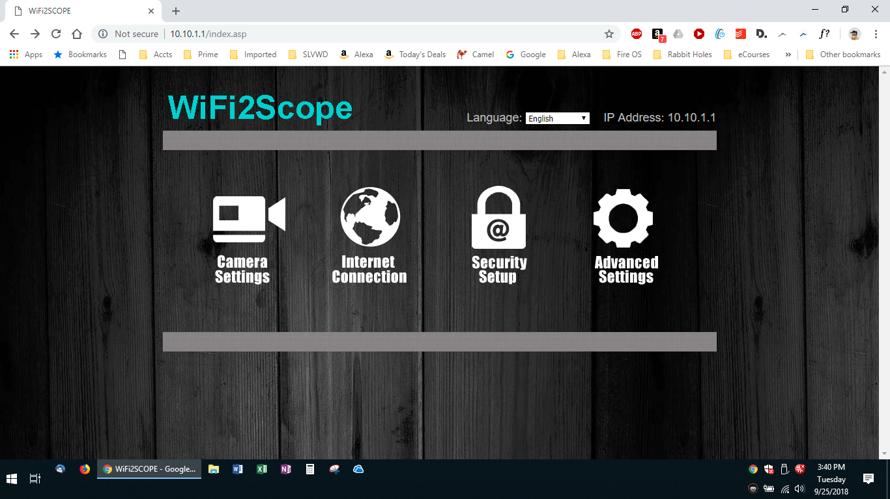
Figure 17 - Setting up an Internet connection step 1

- Select “Wireless AP Client Mode” and “Next” as indicated in the screenshot below:
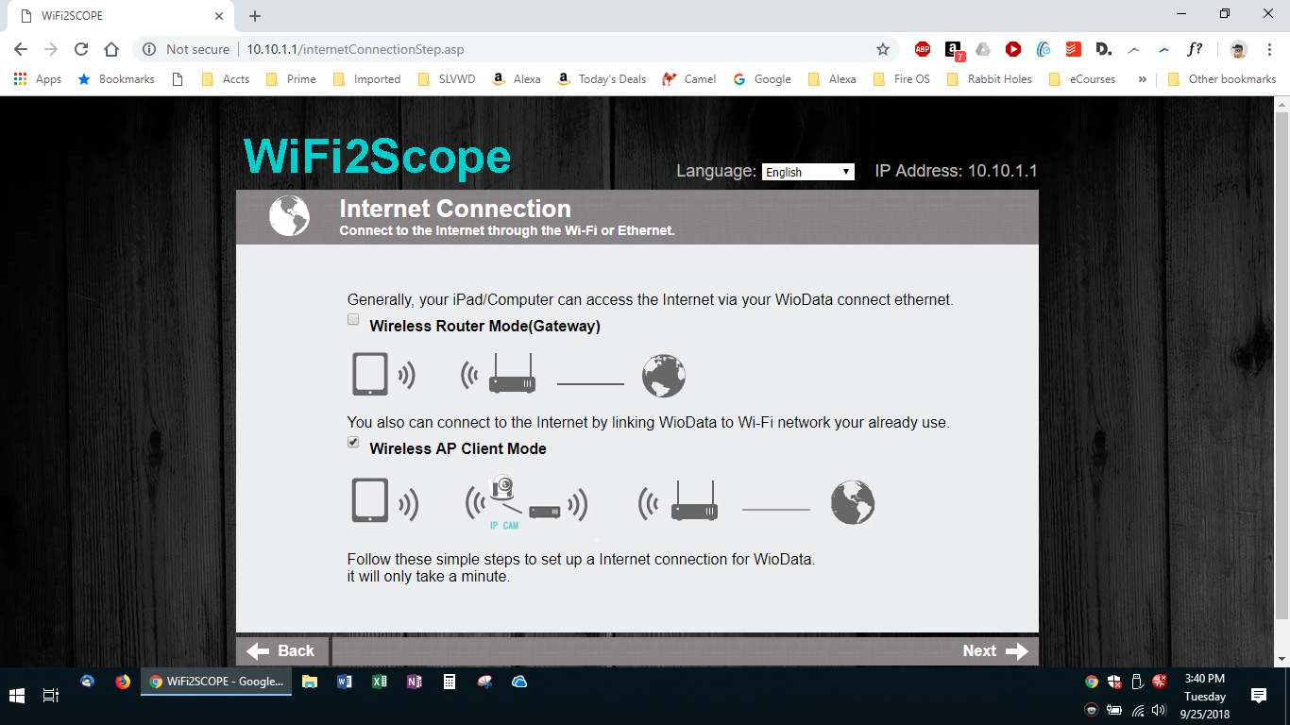
Figure 18 - Setting up an Internet connection step 2

- This will bring you to the screen below. You want to find your router’s WiFi signal in the list; you may have to click “Refresh” (as indicated below) several times to find your router
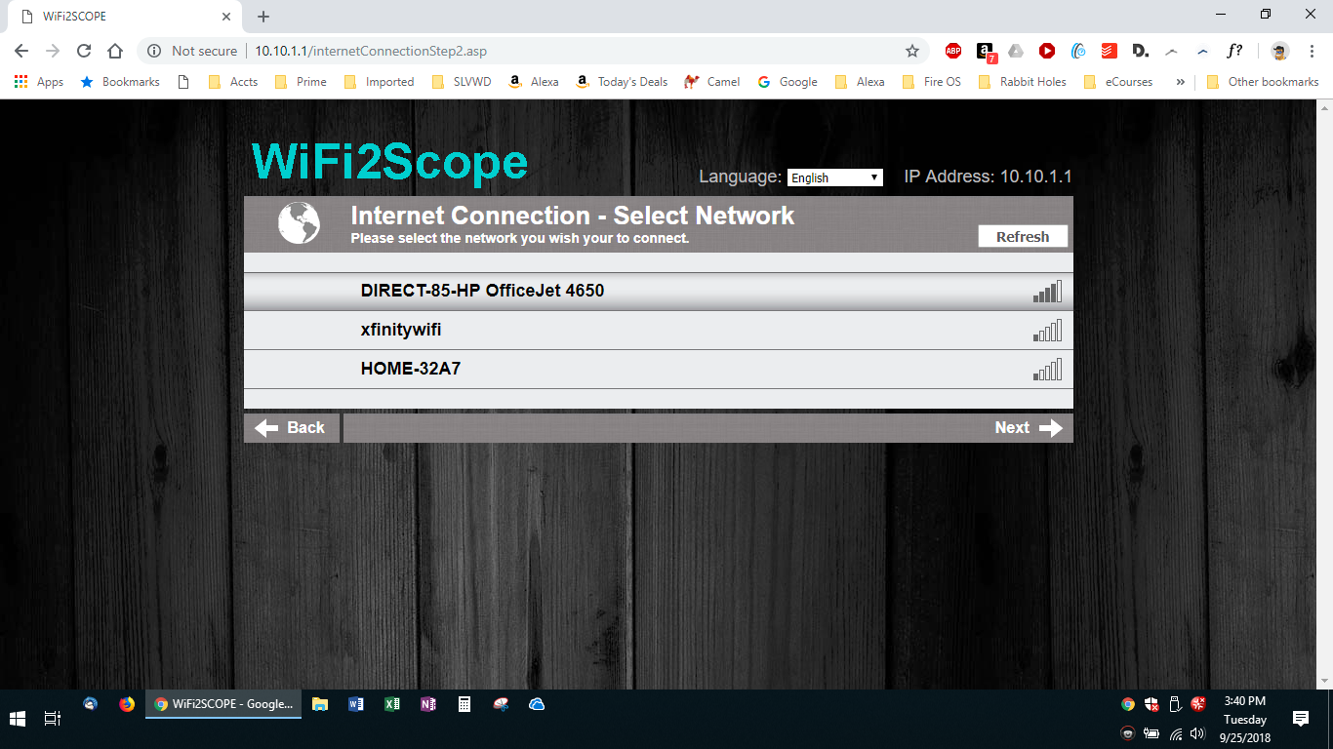
Figure 19 -- Setting up an Internet connection step 3a
- Once you find your router and click on it you will be asked for the router’s password. Once you supply that, you will get the following two screens (automatically):
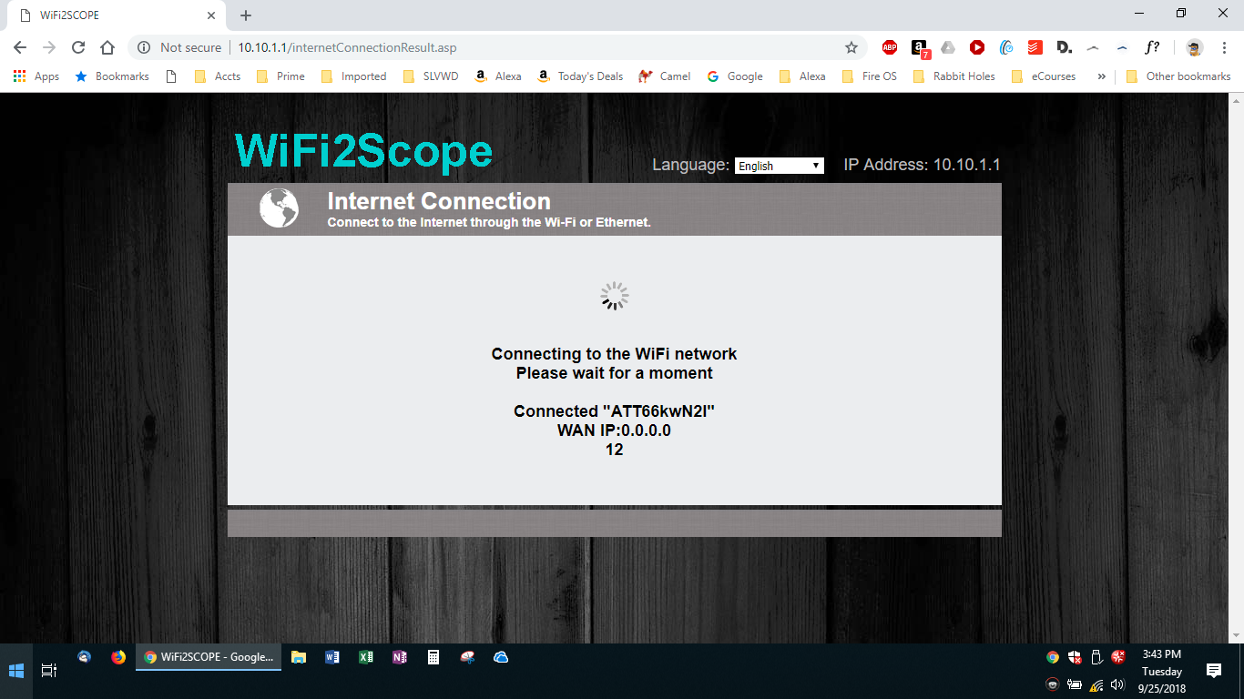
Figure 20- - Setting up an Internet connection step 3b
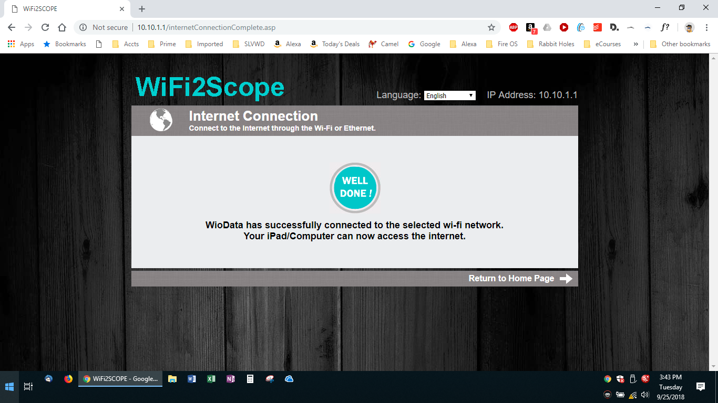
Figure 21- - Setting up an Internet connection step 3c
- You should close this browser window once the connection is made, and re-open any you may need.
- When you are done using the WiFiScope, you may have to manually re-connect your device to your wireless router signal if it does not re-connect automatically.

Case 3: Using a Second WiFi transceiver
If your display device has an open USB connection available, you can add an inexpensive, external, second WiFi transceiver device, and connect to the WiFiScope and your wireless router at the same time.
The screenshot below is of a “normal” device, (i.e., one with only one (internal) WiFi transceiver): Notice there is “nothing” above the first WiFi signal that this device is detecting.
Figure 22 - Device with only one Wifi transceiver attached

Compare that to the screenshot below, taken after the external WiFi transceiver has been plugged in – there is now a “drop-down” box, with “Wi-Fi” above the first WiFi signal:
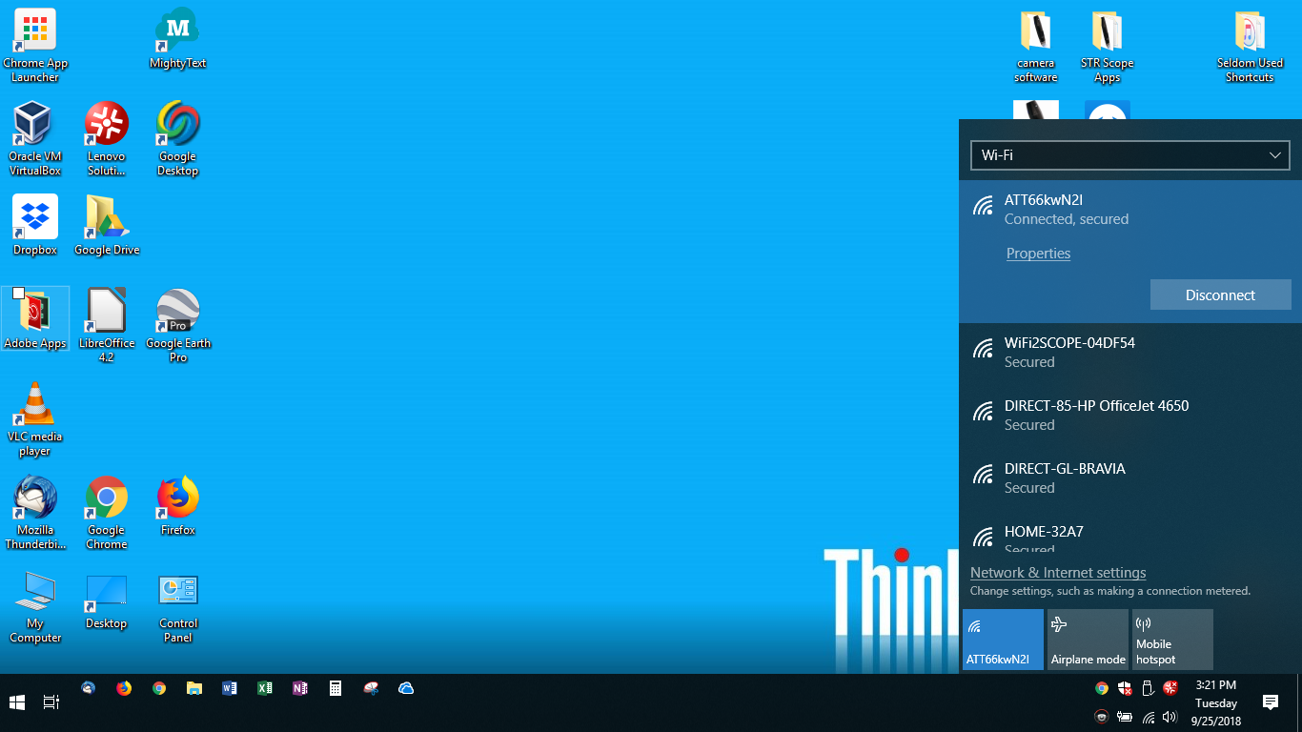
Figure 23 - Device with more than one Wifi transceiver attached
Clicking on the “drop-down” arrow reveals the second transceiver, “Wi-Fi 2”
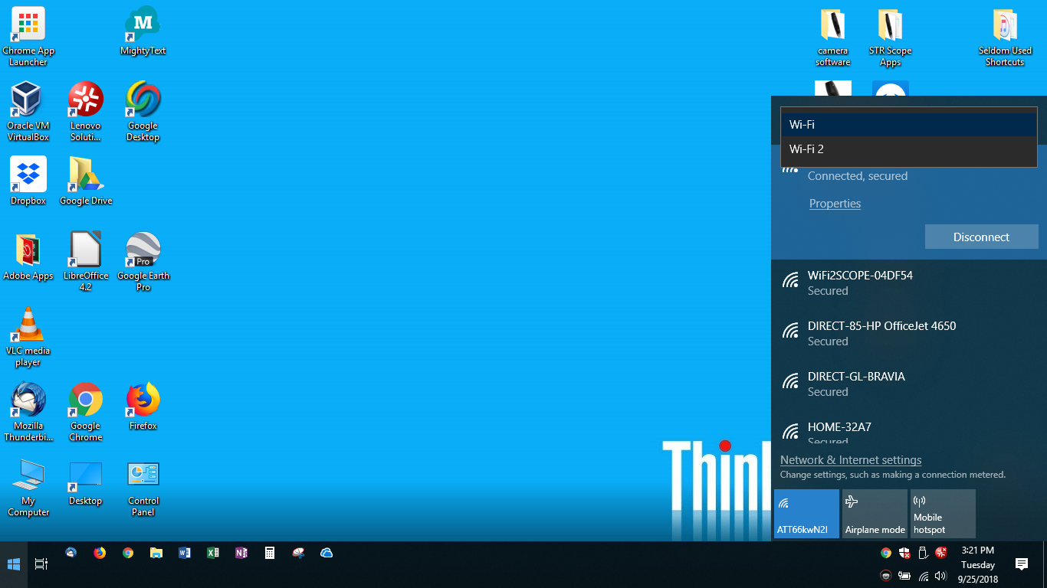
Figure 24 - Multiple WiFi tranceivers
These 2 WiFi devices can now be used independently to connect the WiFiScope and your wireless router connection.
Depending on how your system is setup, and assuming you leave the external WiFi Receiver / Transmitter connected, your WiFiScope may automatically connect when you turn it on for subsequent uses.

Appendix 2a: USB Connections, Levels and Types -. Just the Basics.
From the earliest days, computers (in the common current nomenclature often referred to as the “host” or “smart” device) sent commands and some associated data to a peripheral device, (and again using the common current nomenclature, the “target” or “dumb” device) such as a printer.
Each USB connection has two distinct characteristics: the level and the type.
- The level refers to the maximum transmission speed and, in later levels, additional capabilities (specifically the electrical power transmission that the connection is capable of supporting,).
  - The level is denoted by a number (e.g., 1.1, 2.0, 3.0, 3.1, etc.) with higher numbers indicating higher speed and greater power capabilities.
  - Two additional designations are sometimes added:
    - “OTG” (for “On-The-Go”). This applies to USB 3.0 and above.
    - “SS” (for “SuperSpeed”). This designation applies to USB 3.1 and above

- The type refers to the physical connectors on the ends of the cable
  - The type is denoted by a letter (e.g., “A”, “B” or “C”).
    - Older devices typically had an “A” connector on one end for the “host” device connection and a “B” connector on the other end for the “target” device connection. While there is essentially only one type of “A” connector, there are multiple type “B” connectors.
    - Newer devices will connect with cables with type “C” connectors on either end.
    - For “backward compatibility” some newer devices will need a “bridge” cable to connect their “C” connector to an older device that uses an “A” connector. This type of connection, along with the “A/B” connection type, will be phased out over time.
Technically, any USB connection should be referred to by both the level and type(s), but in many cases one or the other is implied by the devices involved or the purpose of the connection, so for simplicity is not stated.

Appendix 2b: USB Connections, Levels and Types - . A Few More Details
From the earliest days, computers (in the common current nomenclature often referred to as the “host” or “smart” device) sent commands and some associated data to a peripheral device, (and again using the common current nomenclature, the “target” or “dumb” device) such as a printer.
- For example, a computer program might send the command “output” to a printer, with the data being “Hello World!”
And on receiving this command (i.e., “output”) the display device would print the data (i.e., “Hello World!”)
- Both the command and the data were sent over either a physical cable, or later, via a wireless connection, a.k.a. “WiFi”.
- And the cable / connector between a computer and a printer might be different than the cable / connector from the computer to a keyboard or mouse. And as more devices (e.g., cameras, scanners, etc.) became available, the more varied the connection became.
And In earlier days, the cables and the connectors were different, depending on the devices (on both “host” and” target” ends).

“The Solution”: USB cables, connectors, and capabilities.
To simplify and standardize the situation, the USB (Universal Serial Bus) architecture was designed. And this architecture was intended to be able to improve over time, and with the idea that later designs would be “backward compatible” – that is “newer” versions that added more or faster capabilities would still work with “older” versions of cables.
Each USB connection has two distinct characteristics: the level and the type.
- The level refers to the maximum transmission speed and, later on, additional capabilities (specifically the electrical power transmission that the connection is capable of supporting,).
  - The level is denoted by a number (e.g., 1.1, 2.0, 3.0, 3.1, etc.).
Without going into all details at all levels, here are some comparisons of maximum speed and power capabilities:
    - USB 1.1: 12 Mbps
    - USB 2.0: 480 Mbps
    - USB 3.1: 10 Gbps
  - Two additional designations are sometimes added:
    - “OTG” (for “On-The-Go”). This will be explained later and applies to USB 3.0 and above.
    - “SS” (for “SuperSpeed”). This designation only applies to USB 3.1 and above
- The type refers to the physical connectors on the ends of the cable
  - The type is denoted by a letter (e.g., “A”, “B” or “C”).
  - In general cables would have a “male” connector on either end, which would plug into a corresponding “female” receptacle on the “host” and the “target” device. The type “A” connector on one end would plug into the “host” and the type “B” connector would plug into the “target” device.
    - Initially, there was only one type “B” connector, which was fairly large. This didn’t really matter, as it was typically plugged into a fairly large device, such as a printer or scanner.
    - But as smaller devices, such as cameras, were introduced, smaller connectors were more desirable. So the “standard B” connector was joined by the smaller “mini B” and then the even smaller “micro B”.
  - In the beginning, and until recently, the “host” or “smart” device would always initiate and control any actions with the “target” or “dumb” device. However, over the last few years some “target” devices became capable of being a “host” also – such as connecting a “smartphone” to a computer.

  - Refer to the chart below for some typical connection types:
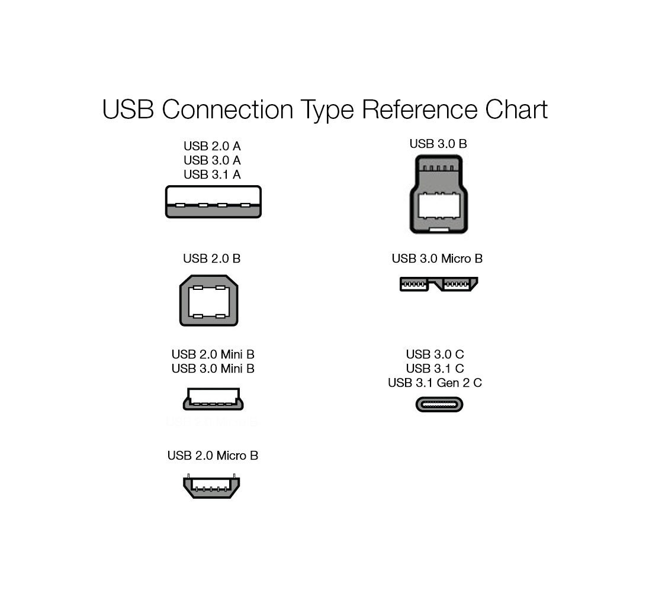
Figure 25 - USB Connector types

We used a TP-Link TL-WN725N N150 USB wireless WiFi network Adapter for PC, purchased from Amazon
Referring to devices as “smart” and “dumb” has been deprecated, with the current preferred terms being “host” and “target”. They are included here for historical reasons and as they are still in use in some older documentation and may be more familiar to more “seasoned” users.
Referring to devices as “smart” and “dumb” has been deprecated, with the current preferred terms being “host” and “target”. They are included here for historical reasons and as they are still in use in some older documentation and may be more familiar to more “seasoned” users.
“WiFi” is not “short” for anything, although it is commonly, if mistakenly, thought to be short for “Wide Fidelity” (which is a phrase that doesn’t really make sense). The engineers that initially developed the technology were audiophiles and “WiFi” was a play on the audio term “HiFi”, which stands for “High Fidelity”, which does have a meaning in audio circles.

